Node RED Application

Contents

Setup 2

Configuring Nodes 3

IBM IoT 3

Weather Forecast (http Request) 4

IBM Watson Machine Learning (http Request) 5

Data Logs to IBM DB2 on Cloud (dashDB out) 6

Get crop data from IBM DB2 on Cloud (dashDB in) 7

Connections 8

# Setup

Create Node RED application

<https://developer.ibm.com/components/node-red/tutorials/how-to-create-a-node-red-starter-application/>

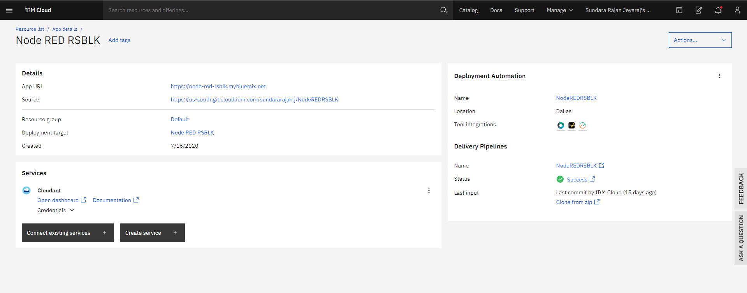

Click on App URL to access Node-RED editor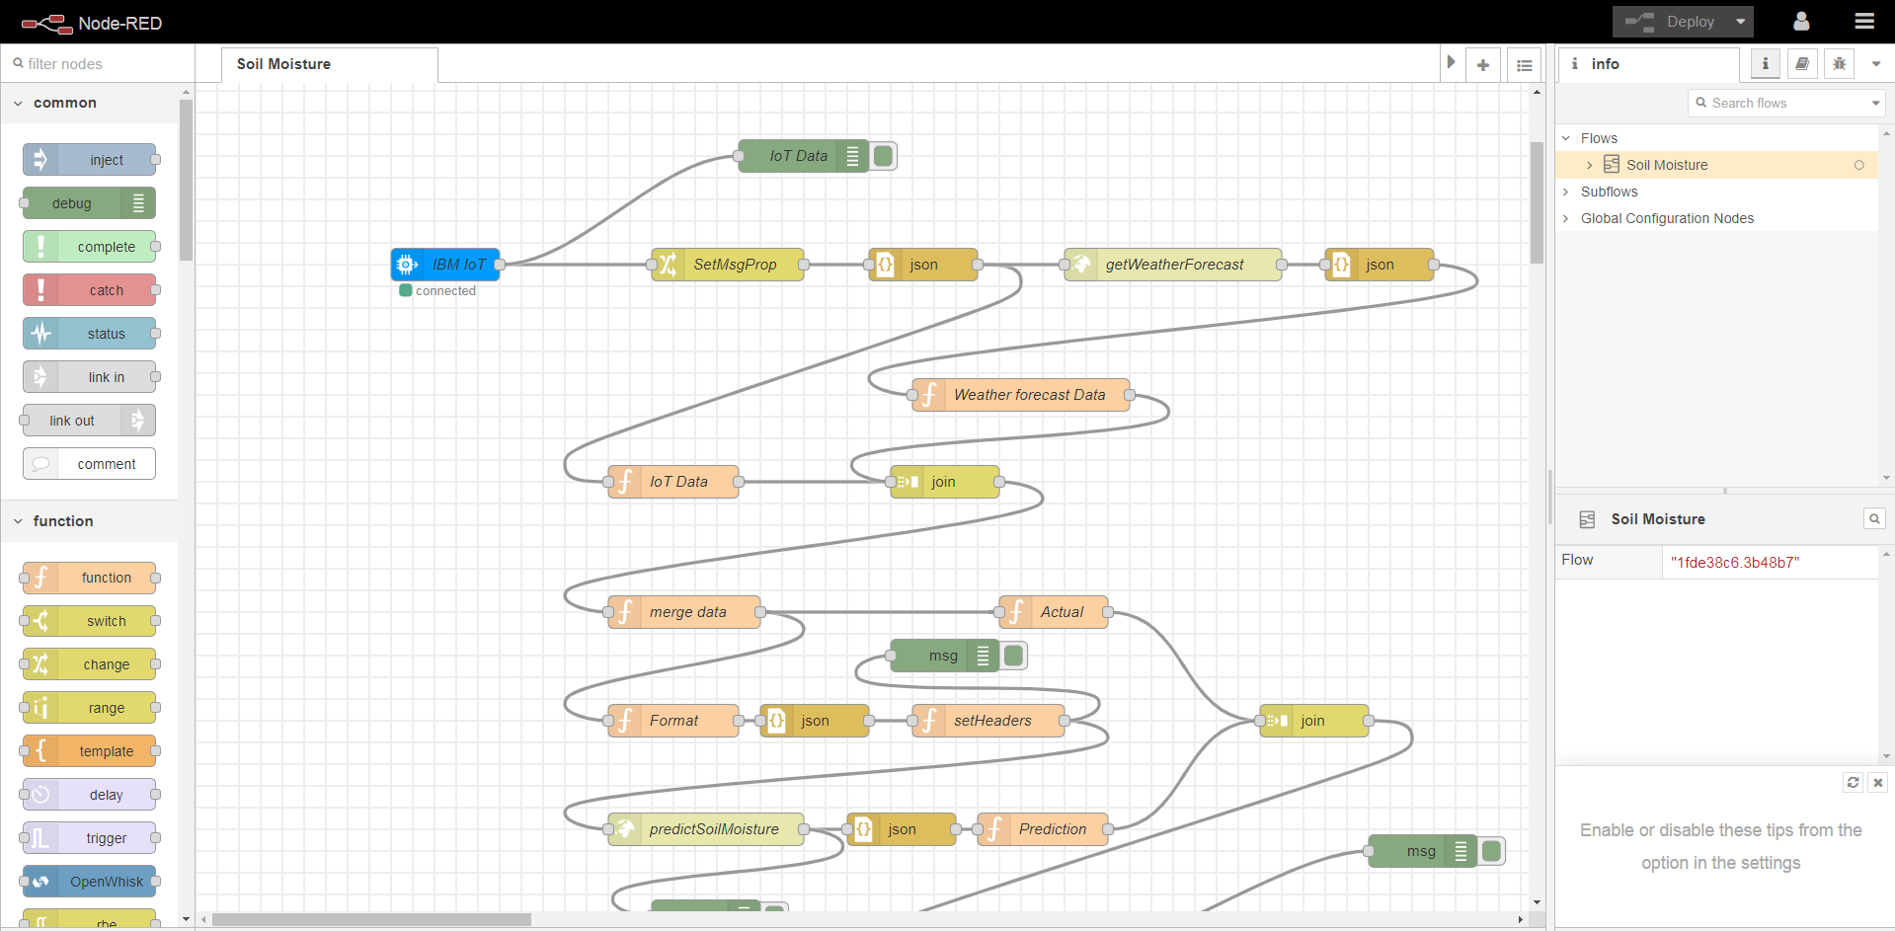

# Configuring Nodes

## IBM IoT

Install node-red-contrib-scx-ibmiotapp from Manage Palette

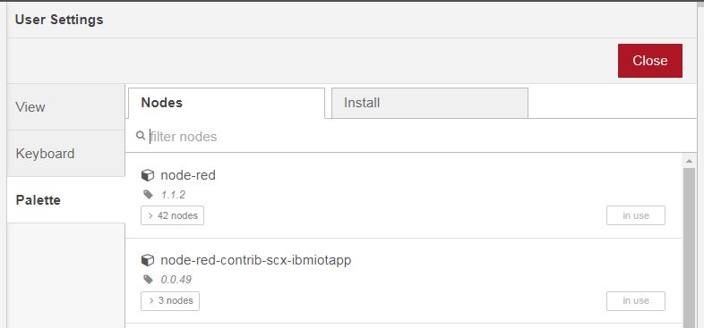

Drag and drop the IBM IoT node into the flow and configure it as shown. 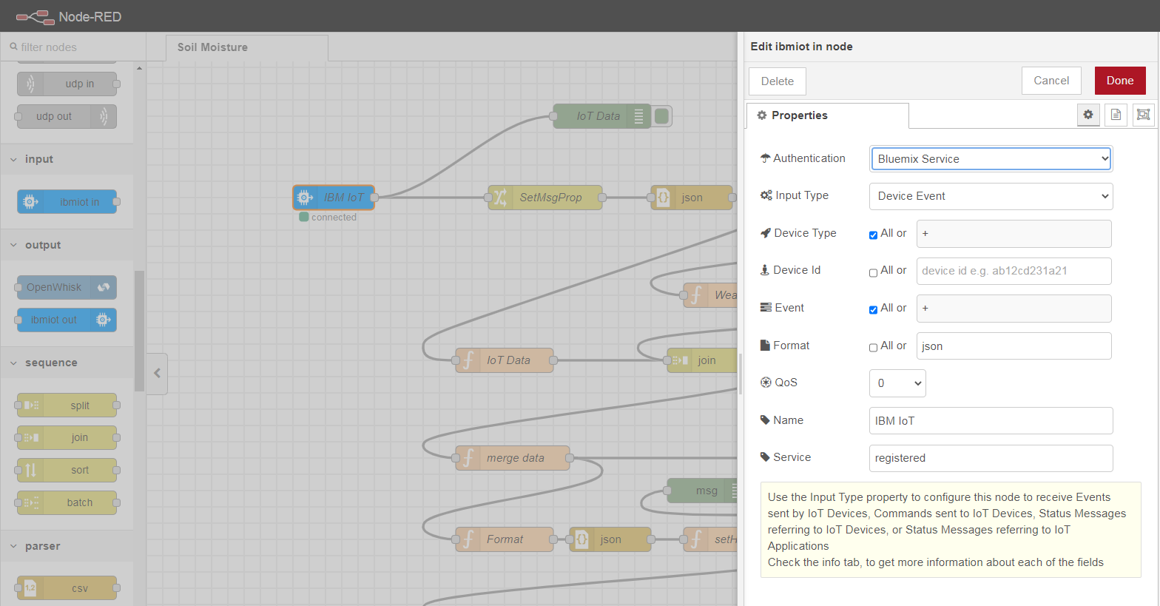

Note: Bluemix Service will be enabled only after creating a connection between Node RED Application and IBM Watson IoT Platform service. Otherwise we can configure using, API Key, API Token of the device registered and Server Name where the devices are registered.

## Weather Forecast (http Request)

Pre-requisite:

1. Sign up at

<https://openweathermap.org/> to get access to Open Weather Map weather forecast APIs

Configure http Request node to get weather forecast by calling Open Weather Map as shown below

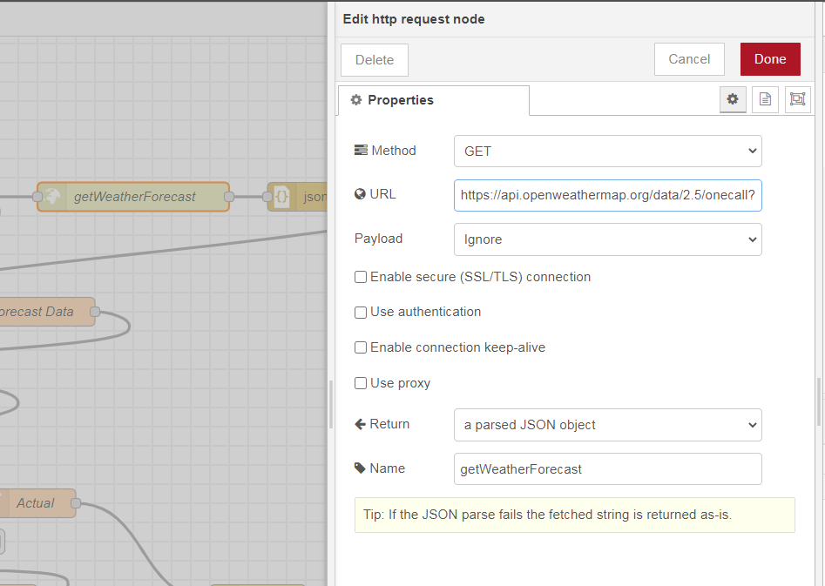

URL: [https://api.openweathermap.org/data/2.5/onecall?lat={{{lat}}}&lon={{{lon}}}&exclude=minutely,daily&units=metric&appid={{{apikey}}}](https://api.openweathermap.org/data/2.5/onecall?lat=%7b%7b%7blat%7d%7d%7d&lon=%7b%7b%7blon%7d%7d%7d&exclude=minutely,daily&units=metric&appid=%7b%7b%7bapikey%7d%7d%7d)

Variables:

1. lat – Latitude
2. lon – Longitude
3. apikey – API Obtained from Open Weather Map site by registering

Note: These variables should be set in the “message” property

## IBM Watson Machine Learning (http Request)

Pre-requisite:

1. An IBM Watson Studio Instance
2. Deploy best model from Auto AI Experiment for our data set as a Web Service in Watson Studio

Node RED Mapping:

1. Method - POST
2. URL - Scoring End-point for our model deployed in Watson Studio
3. Input message header
   1. Content-Type - 'application/json'
   2. Accept - 'application/json'
   3. Authorization - Authorization: Bearer <token> from Deployed Model (Watson Studio)
   4. ML-Instance-ID - from Deployed Model (IBM Cloud CLI)

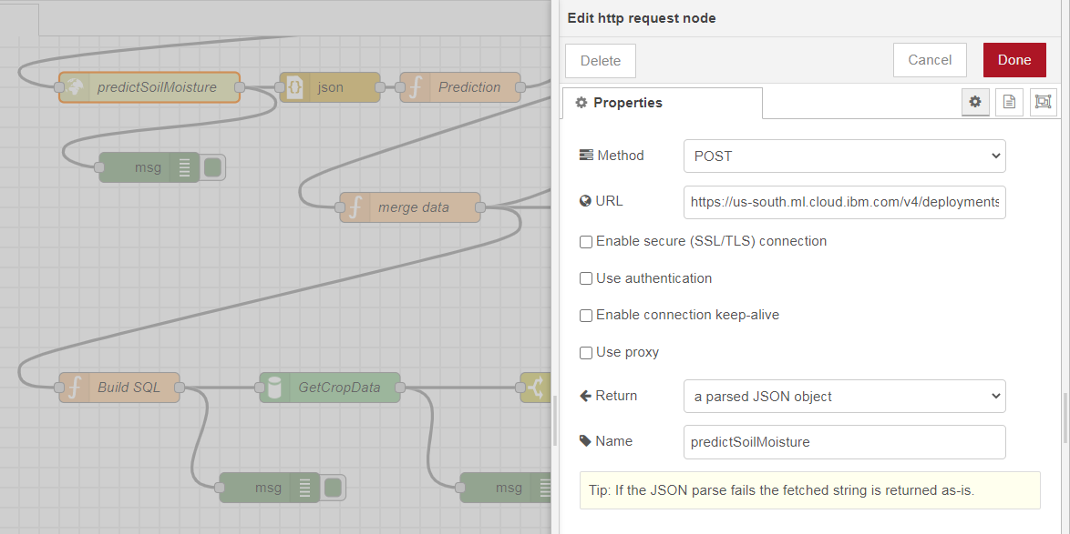

Snippet for deployed model from Watson Studio

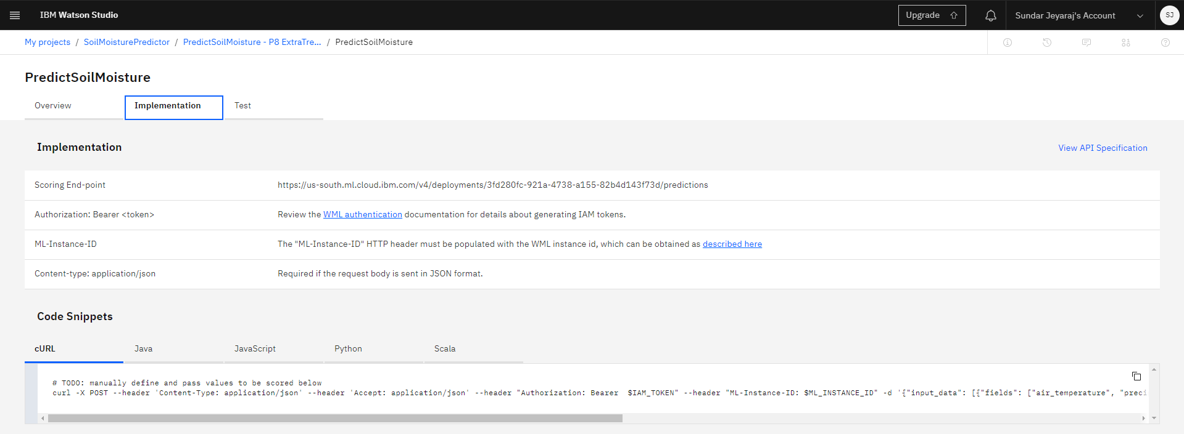

## Data Logs to IBM DB2 on Cloud (dashDB out)

Pre-requisite:

1. An IBM DB2 on Cloud Instance
2. Table “SOIL_MOISTURE_LOG” created in DB2
3. Connection created between Node RED and DB2

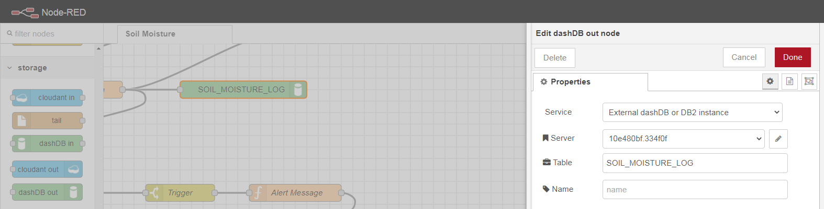

Server configuration

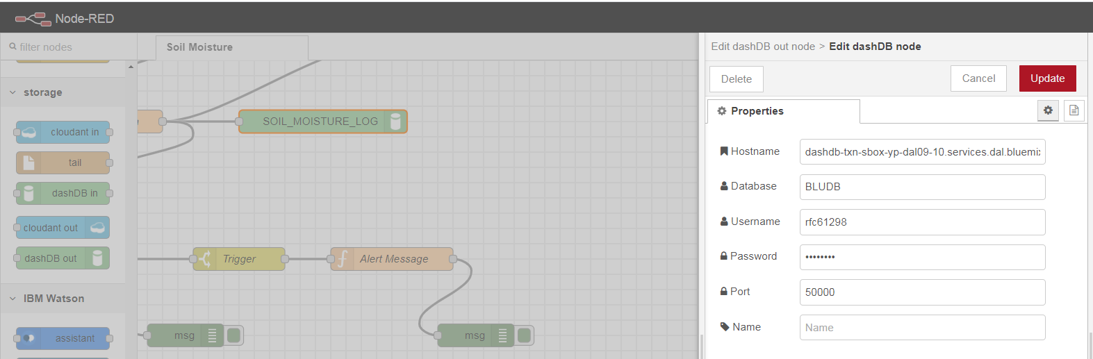

Get values for parameters from “Service Credentials” of DB2 instance

Note: This is created only after connection is established between Node RED and DB2

1. Hostname - hostname
2. Database - db
3. Username - UID(dsn)
4. Password – PWD(dsn)
5. Port – PORT(dsn)

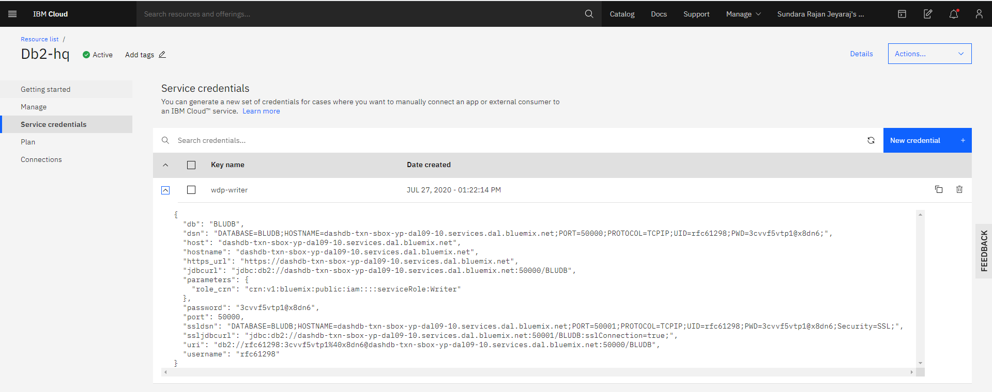

## Get crop data from IBM DB2 on Cloud (dashDB in)

Pre-requisite:

1. An IBM DB2 on Cloud Instance
2. Table “CROP_DATA” created in DB2
3. Connection created between Node RED and DB2

Select the DB2 instance in “Service” parameter

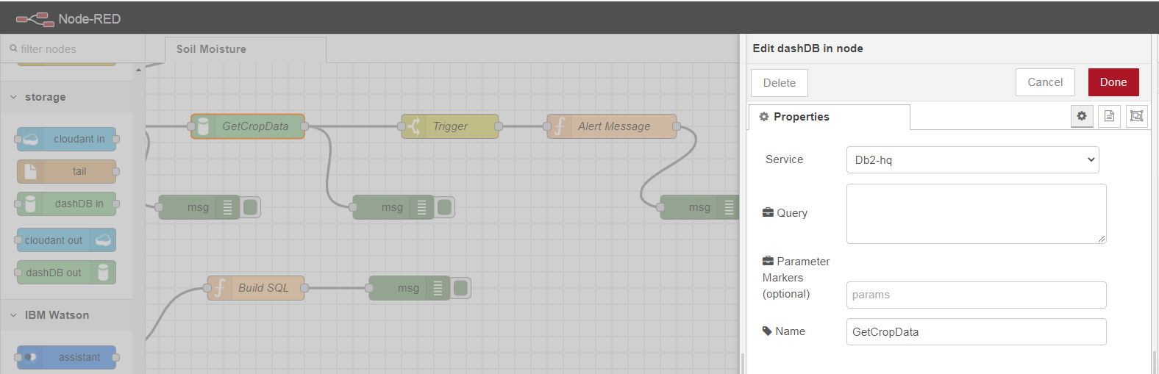

Function Node sets query to be executed as payload which is passed as input to this “dashDB” in Node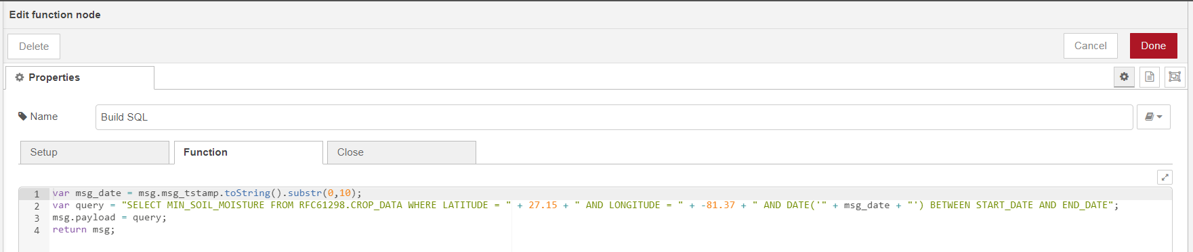

## Connections

Key list of connections to other IBM Cloud Resources

1. Node RED code deployment to IBM Cloudant service
2. Node RED code storage in IBM Cloud Object Storage
3. IBM Watson IoT Platform service
4. IBM DB2 on Cloud data base

